WEEK 4 REPORT
SPLUNK, WAZUH AND LOG INGESTION

Cybersecurity Internship Weekly Report

Prepared By | Devangi Khatri
Program | DG Interns Hub
Reporting Period | Week 4
Focus | Splunk , Wazuh & Log Ingestion
Submission deadline | 15th November 2026, 11:59 PM IST

1. INTRODUCTION
Cybersecurity is an important part of protecting computer systems, networks, applications and sensitive information from unauthorized access and cyber threats.
Organizations generate large amounts of security data through operating systems, servers, applications, firewalls and network devices. These systems generate logs that record different activities, including user logins, process execution, network connections and system changes.
However, collecting logs individually is not enough to identify complex security threats. Security teams need a centralized platform to collect, monitor, correlate and analyze security events.
Security Information and Event Management (SIEM) helps organizations perform these activities.
During Week 4 of the DG Interns HUB Cybersecurity Internship, I focused on understanding and implementing SIEM concepts using Splunk Enterprise and Wazuh.
I performed practical activities related to log ingestion, endpoint monitoring, security detection, alert investigation and threat analysis.
This week helped me understand how SOC analysts use SIEM platforms to monitor systems, identify suspicious activities and investigate potential security incidents.

2. OBJECTIVES
The main objectives of this week were:
- Understand the concept and importance of SIEM.
- Learn SIEM architecture and log collection methods.
- Install and configure Splunk Enterprise.
- Understand Splunk Search Processing Language (SPL).
- Collect Windows and Linux security logs.
- Install and configure Wazuh.
- Monitor endpoint activities using security agents.
- Understand File Integrity Monitoring (FIM).
- Perform controlled security testing in a lab environment.
- Detect brute-force attempts and network scanning activities.
- Create custom SIEM detection searches and alerts.
- Investigate and classify security alerts.
- Understand SOC analyst responsibilities and alert triage.

3. TOOLS AND TECHNOLOGIES USED
The following tools and technologies were used during the practical activities.
Tool / Technology | Purpose
Splunk Enterprise | Centralized log searching, monitoring and analysis
Splunk Universal Forwarder | Forwarding endpoint logs to Splunk
Wazuh | Endpoint security monitoring and threat detection
Sysmon | Monitoring Windows process and network activities
Kali Linux | Security testing and network analysis
Ubuntu Linux | Linux server and authentication log collection
Windows | Endpoint security monitoring
Nmap | Network scanning and service discovery
Hydra | Controlled authentication testing
Wireshark | Network traffic analysis
MITRE ATT&CK | Understanding and mapping attacker techniques

4. THEORETICAL LEARNING
During Week 4, I studied eight major theoretical topics.
4.1 Introduction to SIEM
SIEM stands for Security Information and Event Management.
It is a security solution that collects, stores, monitors and analyzes logs from different sources to identify suspicious activities and potential security threats.
Main Functions:
- Centralized log collection.
- Security event monitoring.
- Threat detection.
- Event correlation.
- Alert generation.
- Incident investigation.
- Security reporting.
4.2 Log Ingestion Methods
Log ingestion is the process of collecting log data from different systems and sending it to a centralized monitoring platform.
Important methods include:
- Agent-Based Collection: An agent is installed on an endpoint to collect and forward logs.
- Agentless Collection: Logs are collected without installing a dedicated endpoint agent, using methods such as Syslog or APIs.
- API-Based Collection: Data is collected through application programming interfaces.
- File Monitoring: A monitoring tool reads log files and forwards new entries.
4.3 Splunk Search Processing Language (SPL)
SPL stands for Search Processing Language.
It is used in Splunk to search, filter, organize and analyze machine-generated data.
Important SPL commands:
- search
- where
- fields
- table
- stats
- eval
- top
- rare
- dedup
- rex
- regex
- timechart
- eventstats
- iplocation
- lookup
Example:
index=lab EventID=4625 | stats count by User| sort - count
This query searches failed login events and counts them by user.
4.4 Wazuh Architecture
Wazuh is an open-source security monitoring platform used for endpoint monitoring, threat detection and security analysis.
Main Components:
- Wazuh Agent – Collects security information from endpoints.
- Wazuh Manager – Processes and analyzes collected events.
- Wazuh Indexer – Stores and indexes security data.
- Wazuh Dashboard – Provides a graphical interface for monitoring and investigation.
Other important concepts include decoders, rules and alert severity levels.
4.5 Alert Classification
Security alerts are classified to help analysts determine whether an activity is suspicious.
- True Positive (TP): A real security threat is correctly detected.
- False Positive (FP): A normal activity is incorrectly detected as a threat.
- True Negative (TN): Normal activity is correctly identified as normal.
- False Negative (FN): A real threat is not detected.
Proper alert classification reduces unnecessary investigation and improves security monitoring.

4.6 Brute Force Detection
A brute-force attack is an attempt to gain unauthorized access by repeatedly trying different passwords.
Common indicators include:
- Multiple failed login attempts.
- Repeated authentication requests.
- Attempts from a single suspicious IP address.
- Successful login after multiple failures.
MITRE ATT&CK Technique: T1110 – Brute Force.
4.7 Correlation and Baselines
Event correlation connects related security events from different sources to provide additional investigation context.
A security baseline represents normal system or user behaviour.
Examples:
- Normal login times.
- Common user activities.
- Expected network connections.
- Regular process execution.
Unusual activities can be identified by comparing events against these baselines.
4.8 SOC Tiers and Triage
A Security Operations Center (SOC) monitors and investigates security events.
SOC L1: Performs initial alert monitoring, validation and classification.
SOC L2: Performs deeper investigation and incident analysis.
SOC L3: Handles advanced threat hunting, complex incidents and detection improvements.
Alert triage helps security teams prioritize and investigate potential incidents.

5. SIEM ARCHITECTURE AND WORKING
A SIEM platform collects security data from multiple sources and processes it for monitoring and investigation.
Basic SIEM Data Flow
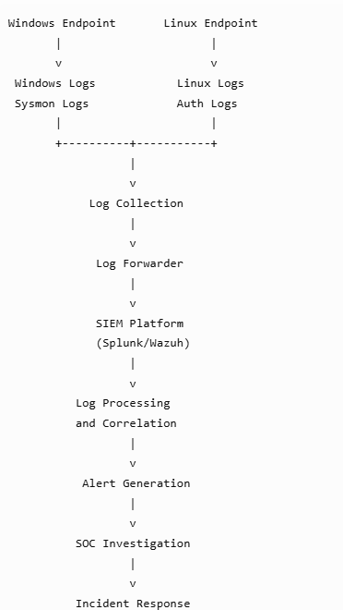
Explanation
- Endpoints generate system and security logs.
- Agents or forwarders collect the logs.
- Logs are transmitted to the SIEM platform.
- The SIEM processes and analyzes the data.
- Detection rules identify suspicious activities.
- Alerts are generated for investigation.
- SOC analysts investigate and document the results.

6. PRACTICAL IMPLEMENTATION
6.1 TASK 1 – SPLUNK ENTERPRISE INSTALLATION
Objective
To install Splunk Enterprise and prepare a centralized environment for security log collection and analysis.
Activities Performed
- Downloaded and installed Splunk Enterprise.
- Configured the initial administrator account.
- Accessed the Splunk web interface.
- Explored the Search and Reporting application.
- Created a custom index named lab.
- Verified the index configuration.
Understanding Indexes
An index is a storage location where Splunk stores and organizes collected machine data.
Example SPL search: index=lab
This query retrieves events stored in the lab index.
Result
Splunk Enterprise was configured as the centralized log analysis platform for the practical activities.
Evidence to attach:
- Splunk installation screenshot.
- Splunk login or dashboard screenshot.
- Custom index creation screenshot.
6.2 TASK 2 – LOG INGESTION
Objective
To collect Windows and Linux security logs and make them available for searching and investigation in Splunk.
Activities Performed
Windows Log Collection
- Configured Splunk Universal Forwarder.
- Collected Windows Security events.
- Configured Sysmon log collection.
- Forwarded endpoint logs to Splunk.

Linux Log Collection
- Configured Ubuntu authentication log collection.
- Monitored /var/log/auth.log.
- Forwarded authentication events to Splunk.
Important Windows Events
Event ID | Description
4624 | Successful login
4625 | Failed login
4720 | User account created
4732 | User added to local security-enabled group
1102 | Security audit log cleared
7045 | New service installed

Example SPL Search
index=lab
To search for failed Windows logins:
index=lab EventID=4625
Log Ingestion Flow
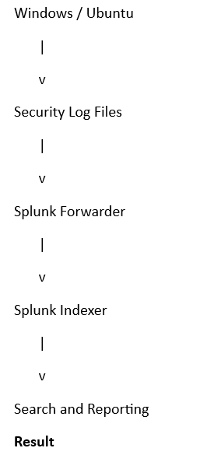
Windows Security logs, Sysmon events and Ubuntu authentication logs were collected and made available for SIEM investigation.

Evidence to attach:
- Forwarder configuration.
- Windows log search results.
- Sysmon event search results.
- Ubuntu authentication log search results.

6.3 TASK 3 – WAZUH INSTALLATION AND CONFIGURATION
Objective
To configure Wazuh for endpoint security monitoring and identify suspicious file modifications through File Integrity Monitoring.
Activities Performed
- Installed Wazuh on Ubuntu.
- Accessed the Wazuh Dashboard.
- Connected the Ubuntu endpoint agent.
- Connected the Windows endpoint agent.
- Verified agent connectivity.
- Configured File Integrity Monitoring.
- Created a test file and modified it.
- Monitored the generated security alert.
File Integrity Monitoring
File Integrity Monitoring (FIM) is a security feature that monitors files and directories for changes.
It can detect:
- File creation.
- File modification.
- File deletion.
- Changes in file attributes.
Wazuh was used to monitor endpoint activities and identify changes in the configured test files.
Evidence to attach:
- Wazuh Dashboard.
- Connected agent status.
- FIM configuration.
- File modification alert.

6.4 TASK 4 – ATTACK-TO-ALERT PRACTICAL
Objective
To understand how controlled security testing activities generate logs and how SIEM platforms can identify suspicious behaviour.
All testing was performed in my own authorized lab environment.
A. SSH Brute-Force Testing
A brute-force attack attempts to discover valid login credentials through repeated password attempts.
Tool Used: Hydra
Target: Own Ubuntu lab VM
Protocol: SSH
Example controlled lab command:
hydra -l testuser -P passwords.txt ssh://<UBUNTU_LAB_IP> -t 2
Investigation
- Monitored SSH authentication attempts.
- Checked failed authentication events.
- Identified the source IP.
- Reviewed the affected username.
- Searched for related events in SIEM.
Example Ubuntu log location:
/var/log/auth.log
B. Nmap SYN Scan
Nmap is a network scanning tool used to identify open ports and services.
A SYN scan sends TCP SYN packets to identify accessible ports.
Example command against an authorized lab target:
nmap -sS <UBUNTU_LAB_IP>
Investigation
- Observed network scanning activity.
- Identified the scanning source.
- Reviewed the target IP and ports.
- Checked available network logs.
- Investigated related SIEM events.

MITRE ATT&CK Mapping
Activity | Technique
SSH Brute Force | T1110 – Brute Force
Nmap SYN Scan | T1046 – Network Service Discovery
Result
The practical demonstrated how security testing activities can generate observable events that analysts can investigate using SIEM tools.
Evidence to attach:
- Hydra command and output.
- SSH authentication log.
- Nmap scan output.
- Related SIEM search results.

6.5 TASK 5 – SIEM DETECTION ENGINEERING
Objective
To create security detection searches and alerts using SPL and Wazuh.
A. SPL Detection 1 – Failed Login Detection
Purpose: Identify failed login attempts.
index=lab EventID=4625 | stats count by User
| sort - count
Security Importance: Helps identify repeated authentication failures and possible brute-force attacks.

B. SPL Detection 2 – PowerShell Process Detection
Purpose: Monitor PowerShell process creation using Sysmon.
index=lab EventID=1 | search Image="*powershell.exe"
| table _time Computer User Image CommandLine ParentImage
Security Importance: Helps analysts investigate suspicious PowerShell execution.

C. SPL Detection 3 – New User Account Detection
Purpose: Identify new account creation.
index=lab EventID=4720
| table _time TargetUserName SubjectUserName Computer
Security Importance: Helps identify unauthorized account creation.

D. SPL Detection 4 – SSH Failed Login Detection
Purpose: Identify repeated SSH authentication failures.
index=lab
("Failed password" OR "Invalid user")
| stats count by src_ip user
| sort - count
Security Importance: Helps identify suspicious SSH login attempts.

E. SPL Detection 5 – Rare Parent-Child Process Detection
Purpose: Identify uncommon parent-child process combinations.
index=lab EventID=1
| stats count by ParentImage Image
| sort count
Security Importance: Helps identify unusual process relationships that may require investigation.

F. Scheduled Alerts
I configured two searches as scheduled alerts.
The purpose of scheduled alerts is to automatically evaluate selected search conditions and notify analysts when the configured conditions are met.
Evidence to attach:
- Alert configuration.
- Alert search results.
- Alert execution evidence.

G. Dashboard Creation
I created a dashboard containing four panels to visualize important security events.
Suggested panel descriptions:
- Failed login activity.
- PowerShell process activity.
- New user account creation.
- SSH authentication failures.
Evidence to attach: Four-panel Splunk dashboard screenshot.

H. Custom Wazuh Rule
I configured a custom Wazuh detection rule using the local rules configuration.
Configuration file:
/var/ossec/etc/rules/local_rules.xml
Custom rules use rule IDs of 100000 or higher.
I used wazuh-logtest to test the custom rule and verify its detection behaviour.
Result: The practical provided experience in creating and testing custom security detections.
Evidence to attach:
- Custom rule configuration.
- Wazuh logtest output.
- Generated Wazuh alert.
6.6 TASK 6 – SECURITY ALERT INVESTIGATION
Objective
To investigate security alerts, understand suspicious activities and classify findings based on available evidence.
I investigated three security alerts as part of the SOC triage activity.

Alert Investigation Methodology
For every alert, I considered the following questions:
Question | Investigation Details
Who? | Which user or account was involved?
What? | What activity occurred?
When? | When did the event happen?
Where? | Which host or IP address was involved?
Why? | Why was the activity suspicious?

Alert 1 – Authentication Failure
Alert Name: Multiple Failed Login Attempts
- Activity: Repeated authentication failures.
- Log Source: Windows Security or Ubuntu authentication logs.
- Investigation: Checked username, source IP and event timestamps.
- Classification: [Enter TP or FP based on your evidence].
- Recommended Action: Review authentication activity and verify whether the attempts were authorized.
Alert 2 – Suspicious Process Activity
Alert Name: PowerShell Process Creation
- Activity: PowerShell process execution.
- Log Source: Sysmon.
- Investigation: Checked process name, command line, parent process and user.
- Classification: [Enter TP or FP based on your evidence].
- Recommended Action: Review the command and determine whether it was legitimate or suspicious.
Alert 3 – File Integrity Change
Alert Name: File Modification Detected
- Activity: A monitored file was changed.
- Log Source: Wazuh FIM.
- Investigation: Checked the affected file, modification time and related user activity.
- Classification: [Enter TP or FP based on your evidence].
- Recommended Action: Verify whether the modification was authorized and investigate unexpected changes.
Importance of Alert Investigation
Alert investigation helps SOC analysts:
- Identify real security threats.
- Reduce false positives.
- Understand the impact of suspicious activities.
- Collect supporting evidence.
- Recommend appropriate response actions.
- Maintain investigation records.
Note: The final classification and exact investigation findings should match the actual evidence collected during the practical.

TASK 7 – SIEM CHEAT SHEETS
Cheat Sheet 1 – SPL Commands
I prepared a reference table containing 20 commonly used SPL commands.
The table includes:
- SPL command name.
- Meaning of the command.
- Practical example.
These commands help perform searching, filtering, data transformation, event analysis and security investigation.
Cheat Sheet 2 – SIEM Alerts
I prepared a reference table containing 15 common SIEM security alerts.
The table includes:
- Alert name.
- Likely cause.
- First investigation check.
These cheat sheets provide a quick reference for common SOC analyst activities.

7. TRYHACKME LAB ACTIVITIES
I completed two TryHackMe labs to strengthen my theoretical and practical understanding of SIEM and Splunk.
7.1 Lab 1 – Introduction to SIEM
Platform: TryHackMe
Objective: To understand the basic concepts, architecture and importance of SIEM.
Topics Learned:
- Introduction to SIEM.
- Centralized log collection.
- Security monitoring.
- Log analysis.
- Threat detection.
- SIEM use in SOC operations.
Learning Outcome:
I understood how SIEM platforms collect security logs from multiple sources and help analysts identify suspicious activities.
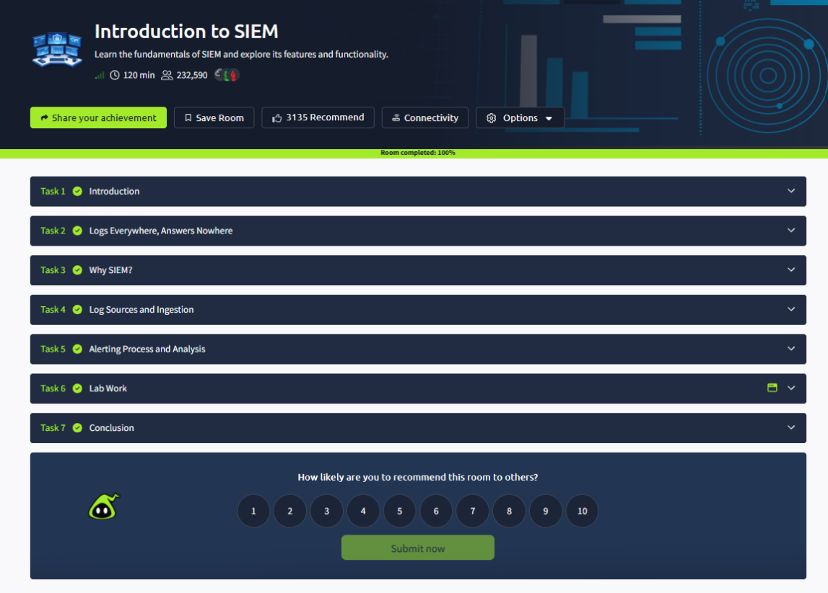

7.2 Lab 2 – Splunk: Exploring SPL
Platform: TryHackMe
Objective: To understand Splunk Search Processing Language and its practical use in security log analysis.
Topics Learned:
- Splunk Search and Reporting.
- Search operators.
- Filtering commands.
- Structuring commands.
- Transforming commands.
- Event correlation.
- Anomaly detection.
Important SPL Commands Practiced:
search, fields, table, stats, eval, eventstats, top, rare, regex, iplocation and join.

Learning Outcome:
I learned how SPL can be used to search, filter and analyze security events and identify unusual user behaviour.
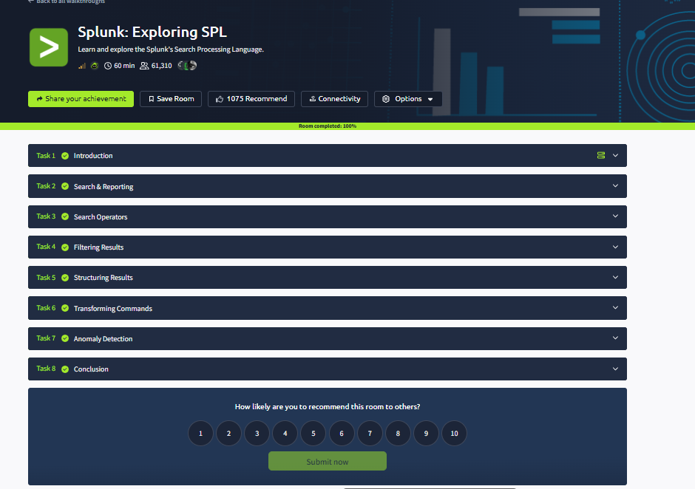

8. SECURITY DETECTIONS AND MITRE ATT&CK MAPPING
MITRE ATT&CK is a knowledge base that describes common tactics and techniques used by cyber attackers.
During Week 4, I studied how security monitoring activities can be mapped to MITRE ATT&CK techniques.
Security Activity | MITRE ATT&CK Technique | Purpose
SSH Brute Force | T1110 – Brute Force | Detects repeated credential guessing
Network Scanning | T1046 – Network Service Discovery | Identifies network reconnaissance
PowerShell Execution | T1059.001 – PowerShell | Monitors command and script execution
New Account Creation | T1136 – Create Account | Identifies account creation activity
MITRE mapping provides additional context for understanding attacker behaviour and improving detection coverage.

9. ALERT CLASSIFICATION AND SOC INVESTIGATION
SIEM platforms generate alerts when defined detection conditions are met.
However, not every alert represents a real attack.
SOC analysts must investigate alerts before deciding how to respond.
Types of Alert Classification
- True Positive: The alert correctly identifies a real suspicious or malicious activity.
- False Positive: The alert identifies normal or authorized activity as suspicious.
- True Negative: Normal activity is correctly treated as normal.
- False Negative: A real suspicious activity is missed by the detection system.

Basic SOC Investigation Workflow
Security Alert
|
v
Initial Validation
|
v
Log Collection
|
v
Event Analysis
|
v
Alert Classification
|
v
Incident Escalation
|
v
Documentation

Importance of SOC Investigation
- Helps identify real threats.
- Reduces unnecessary alerts.
- Supports incident response.
- Improves detection rules.
- Helps maintain security visibility.

10. CHALLENGES FACED AND SOLUTIONS
During Week 4, I faced different challenges while configuring SIEM platforms and performing practical exercises.
Challenge | Solution / Approach
Understanding SIEM architecture | Reviewed the role of agents, managers, indexers and dashboards
Splunk log ingestion configuration | Checked forwarding configuration and log sources
Identifying correct log fields | Examined event details and available fields
Writing SPL queries | Practiced commands and tested search conditions
Connecting Wazuh agents | Checked agent configuration and connectivity
Configuring File Integrity Monitoring | Reviewed monitored directories and file changes
Understanding security alerts | Analyzed timestamps, users, IP addresses and event details
Creating detection rules | Reviewed rule structure and tested using Wazuh logtest
Investigating suspicious activity | Compared related events and reviewed supporting logs
I addressed these challenges through practical testing, reviewing documentation, checking configurations and analyzing generated security events.

11. LEARNING OUTCOMES
After completing Week 4, I gained practical knowledge and understanding of the following areas:
- SIEM concepts and architecture.
- Centralized security log collection.
- Splunk Enterprise installation and configuration.
- Splunk Search Processing Language.
- Windows Security and Sysmon log analysis.
- Linux authentication log monitoring.
- Wazuh endpoint monitoring.
- File Integrity Monitoring.
- Brute-force detection.
- Network scanning detection.
- Custom security detection rules.
- Scheduled alerts and dashboards.
- MITRE ATT&CK technique mapping.
- SOC alert investigation and classification.
- Basic incident response and documentation.
12. CONCLUSION
Week 4 of the DG Interns HUB Cybersecurity Internship provided valuable practical knowledge about Security Information and Event Management.
Throughout the week, I learned how SIEM platforms collect, process and analyze security logs from Windows and Linux endpoints.
I gained hands-on experience with Splunk Enterprise and Wazuh, including log ingestion, endpoint monitoring, File Integrity Monitoring, SPL searches, scheduled alerts and custom detection rules.
I also performed controlled security testing using Hydra and Nmap to understand how suspicious activities generate observable security events.
The alert investigation exercises helped me understand how SOC analysts validate alerts, identify suspicious behaviour, classify findings and document investigation results.
Overall, this week improved my practical understanding of security monitoring, threat detection, log analysis and SOC operations.
The knowledge and skills gained during this internship will help me continue developing my cybersecurity and SOC analyst capabilities.

13. SCREENSHOTS AND PRACTICAL EVIDENCE
Attach actual screenshots under the following categories.
13.1 Splunk Enterprise
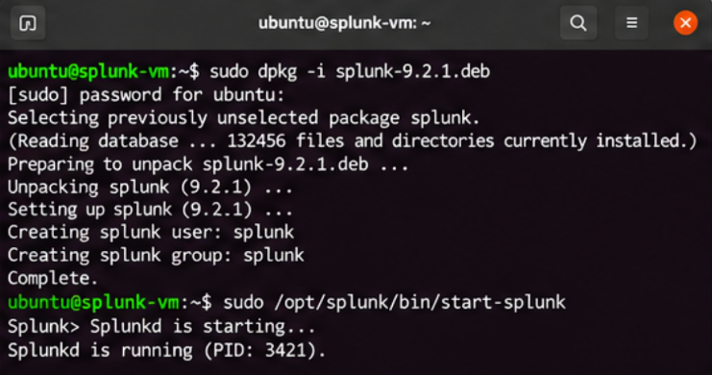
Splunk installation.
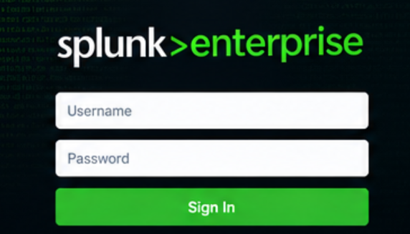
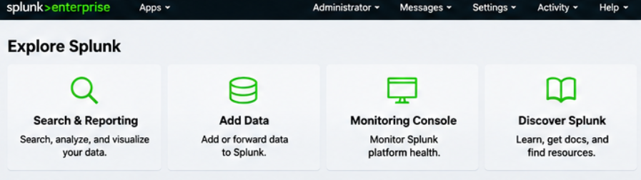
Splunk login and dashboard.

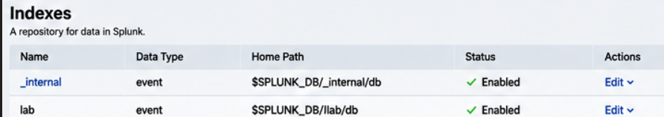
Custom index creation.

13.2 Log Ingestion
1. Install splunk
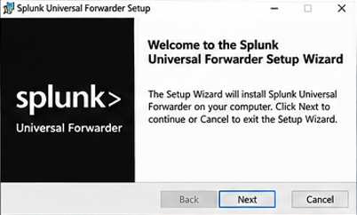
2. Sysmon event
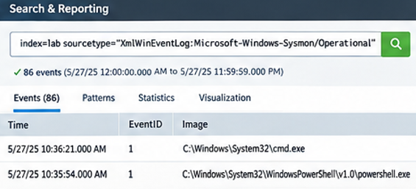

3. Successful log search results
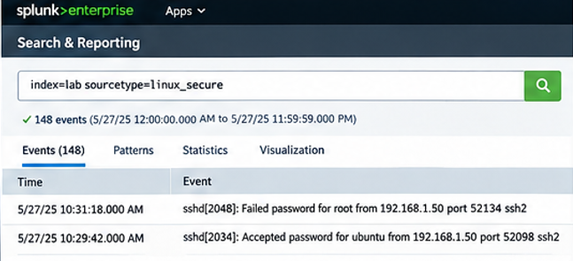

13.3 Wazuh
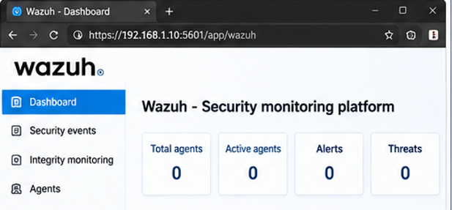
Wazuh Dashboard.
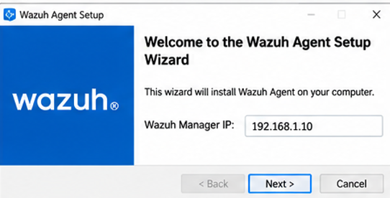
Windows agent status.
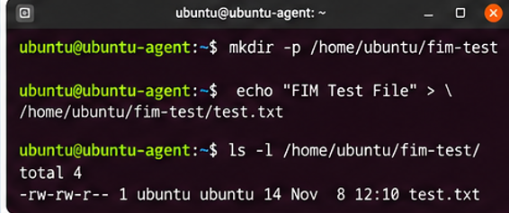
File Integrity Monitoring configuration.
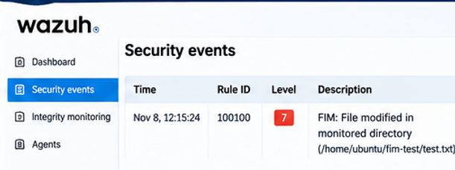
File modification alert.

13.4 Attack-to-Alert Practical
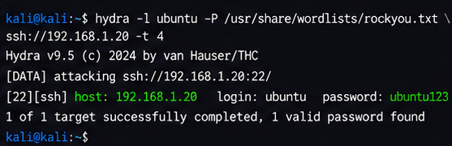
Hydra testing command.
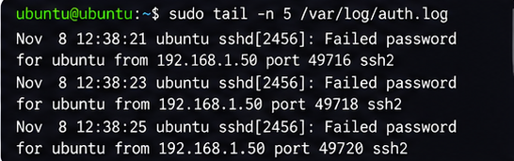
SSH failed login logs.
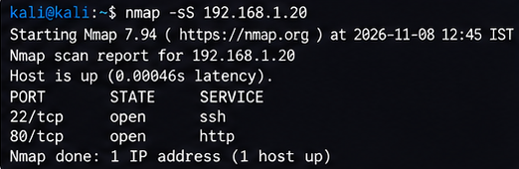
Nmap SYN scan command.
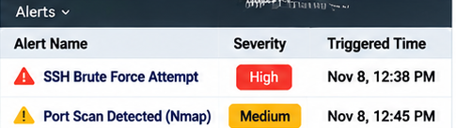
SIEM search results.
13.5 Detection Engineering
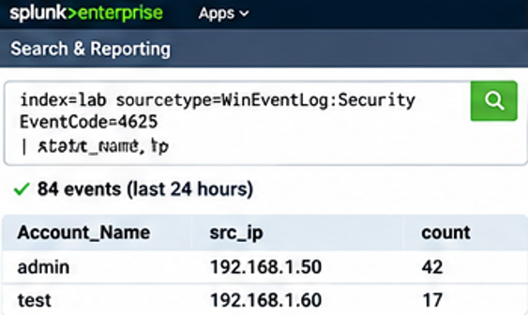
Failed login detection.
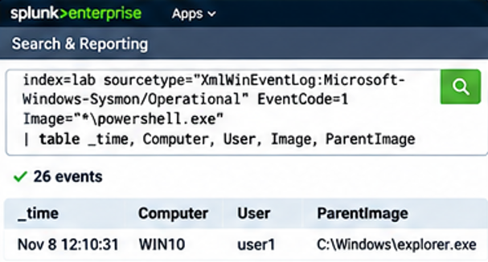
PowerShell process detection.
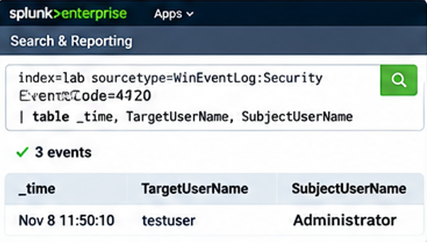
New user detection.
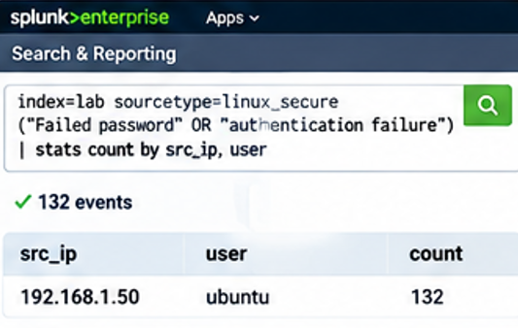
SSH failed login detection.
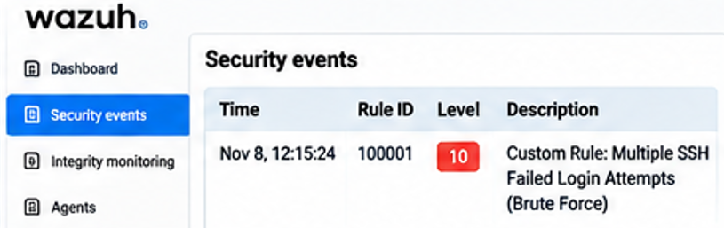
Wazuh logtest output.

13.6 Alert Investigation
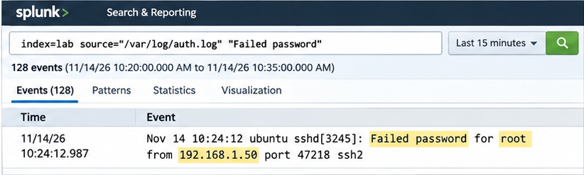
Alert investigation 1
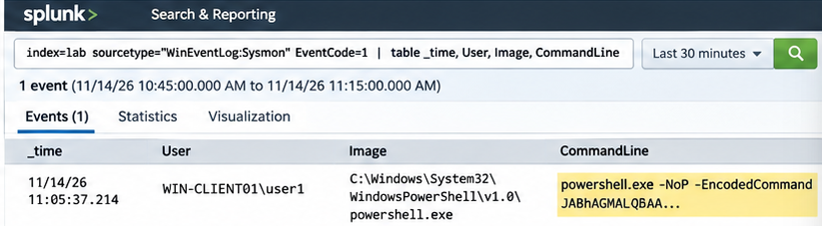
Alert investigation 2.
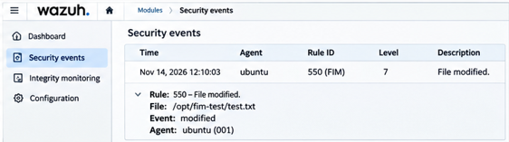
Alert investigation 3.

13.7 Cheat Sheets
- SPL Commands Cheat Sheet.
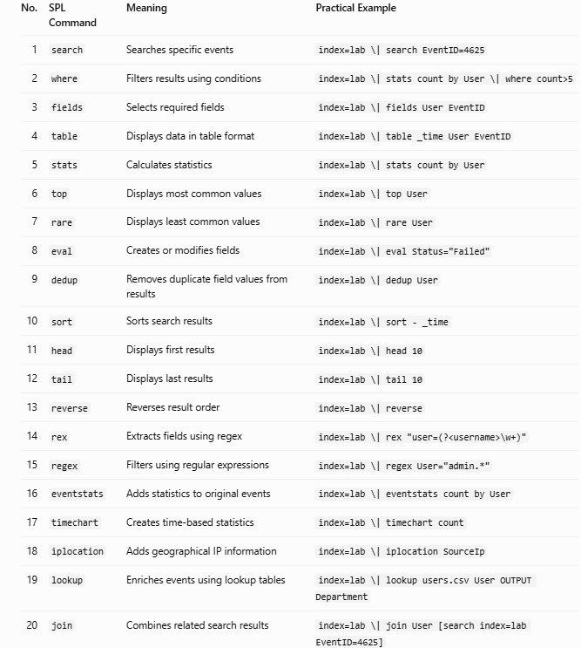

- SIEM Alerts Cheat Sheet.
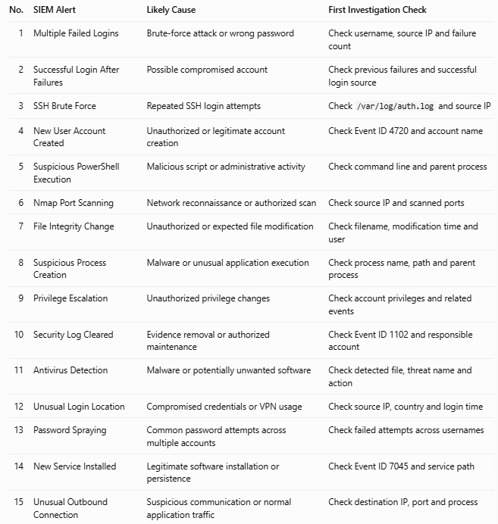
14. REFERENCES
- Splunk Documentation – https://docs.splunk.com/
- Wazuh Documentation – https://documentation.wazuh.com/
- MITRE ATT&CK Framework – https://attack.mitre.org/
- TryHackMe – https://tryhackme.com/
- Nmap Documentation – https://nmap.org/book/
- Wireshark Documentation – https://www.wireshark.org/docs/
- Sysmon Documentation – https://learn.microsoft.com/en-us/sysinternals/downloads/sysmon

